

OPERATING SYSTEMS – PROCESS LAB

Samjhana Dahal
Bsc (Hons) Computer Science with Artificial Intelligence
Softwarica College of IT and E-commerce ST5003CMD
Operating Systems, Security, and Networks
Rupak Rajbanshi
26th September 2026

Table Of Contents
Introduction: 2
Task 1 – Long-Running Process 2
Task 2 – Process Identity 6
Task 3 – Exit Status and Error Handling 8
Task 4 – Standard I/O Streams 10
Task 5 – Conditional Execution and Termination 12

Table Of Figure
Figure 1: Linux terminal commands 3
Figure 2:C program with timed loop 4
Figure 3: Compiling C program with GCC 5
Figure 4: Executing C program output 6
Figure 5: Process check with ps and grep 7
Figure 6: Editing task2_identity.c in Nano 7
Figure 7: Process ID and Parent ID program 8
Figure 8: Compiling and executing task2_identity program 9
Figure 9: Process details with ps command 9
Figure 10: task3_status.c in Nano 9
Figure 11: Success/Failure status program 10
Figure 12: Compiling and executing task3_status program 11
Figure 13: task4_input.c in Nano 11
Figure 14: User input greeting program 12
Figure 15: Compiling and executing task4_input program 13
Figure 16: task5_control.c in Nano 13
Figure 17: Continue or exit control program 14
Figure 18: Compiling and executing task5_control program 15
Figure 19: Detailed file listing with ls -l 15

Introduction:
This lab demonstrates basic Linux process concepts using C programs. The tasks cover process execution, process IDs, exit status, standard input, and conditional termination.

Task 1 – Long-Running Process
Terminal session showing OS lab setup with directory creation, GCC version check, and source file editing.
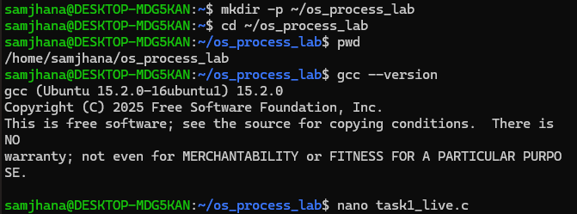

Figure 1: Linux terminal commands

C program in Nano demonstrating a timed loop with console output and one-second delays.
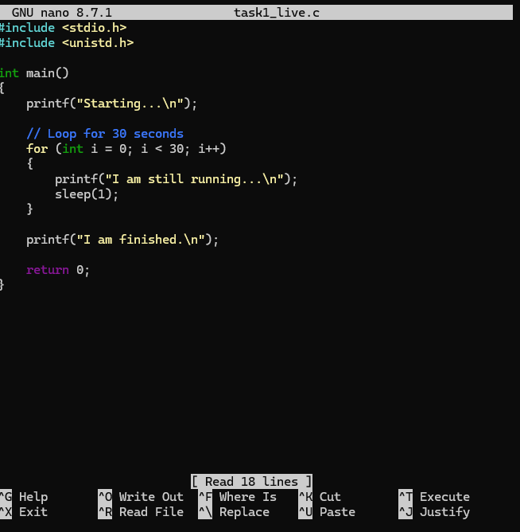
Figure 2:C program with timed loop

Terminal output showing compilation of a C program with GCC and verification of executable creation.
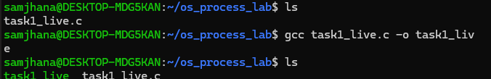
Figure 3: Compiling C program with GCC

Terminal execution of compiled C program showing live process output with iterative status messages and completion notice.

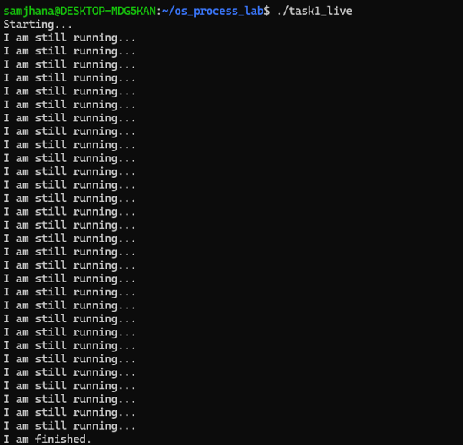
Figure 4: Executing C program output

Terminal command output showing process check with ps aux | grep, confirming that the program task1_live is not actively running.

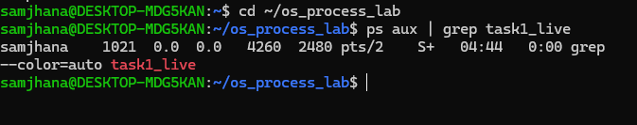
Figure 5: Process check with ps and grep

Task 2 – Process Identity
Terminal session showing navigation to lab directory and opening of task2_identity.c in Nano for editing.
Figure 6: Editing task2_identity.c in Nano

C program in Nano displaying process identification using PID and PPID, followed by a timed sleep.
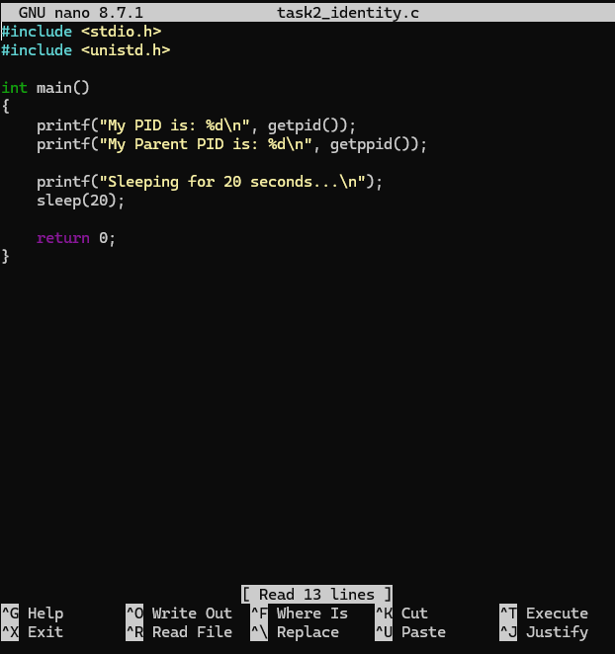
Figure 7: Process ID and Parent ID program

Terminal compilation and execution of task2_identity.c, displaying process ID, parent process ID, and a timed sleep message.
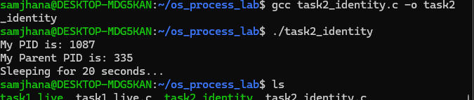
Figure 8: Compiling and executing task2_identity program
Terminal command using ps to check process details, showing no active instance of task2_identity running.
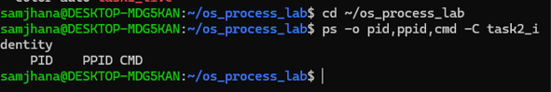
Figure 9: Process details with ps command

Task 3 – Exit Status and Error Handling
Terminal session showing navigation to lab directory and opening of task3_status.c in Nano for editing.
Figure 10: task3_status.c in Nano

C program in Nano demonstrating conditional logic with user input, returning success or failure based on number sign.
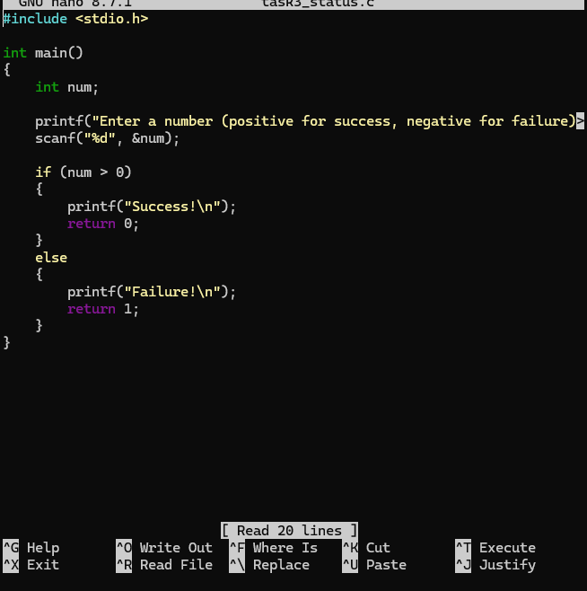
Figure 11: Success/Failure status program

Terminal compilation and execution of task3_status.c, demonstrating conditional input handling with success/failure output and exit status codes.
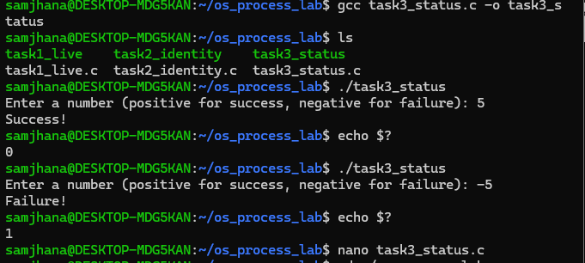
Figure 12: Compiling and executing task3_status program

Task 4 – Standard I/O Streams
Terminal session showing navigation to lab directory and opening of task4_input.c in Nano for editing.
Figure 13: task4_input.c in Nano

C program in Nano prompting user input and displaying a personalized greeting message.
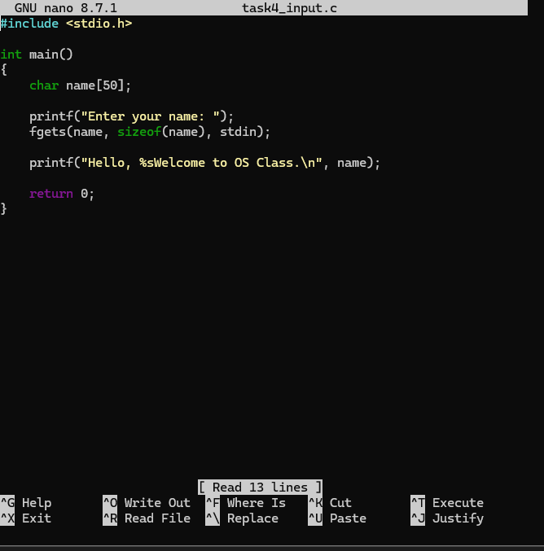
Figure 14: User input greeting program

Terminal compilation and execution of task4_input.c, demonstrating user input handling with personalized greeting and a shell syntax error attempt
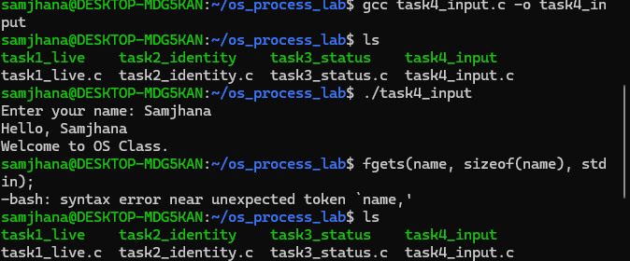
Figure 15: Compiling and executing task4_input program

Task 5 – Conditional Execution and Termination
Terminal session showing navigation to lab directory and opening of task5_control.c in Nano for editing.
Figure 16: task5_control.c in Nano

C program in Nano demonstrating control flow with user input, prompting continuation or exit based on choice.
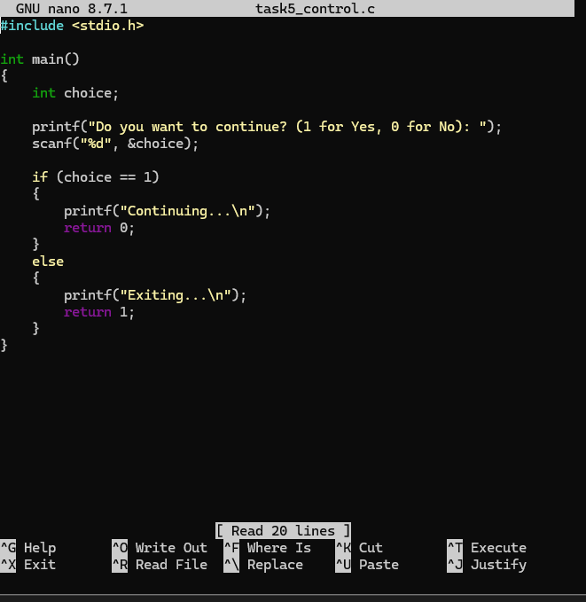
Figure 17: Continue or exit control program

Terminal compilation and execution of task5_control.c, demonstrating user choice handling with continuation or exit messages and corresponding exit status codes.
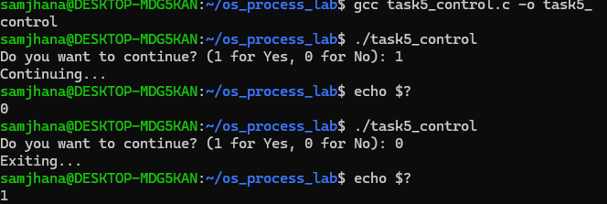
Figure 18: Compiling and executing task5_control program

The image displays the ls -l output, showing the source files and executable programs for Tasks 1–5 in the os_process_lab directory.
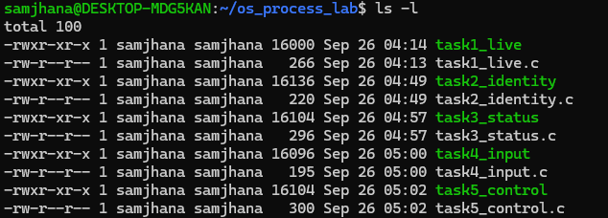
Figure 19: Detailed file listing with ls -l

